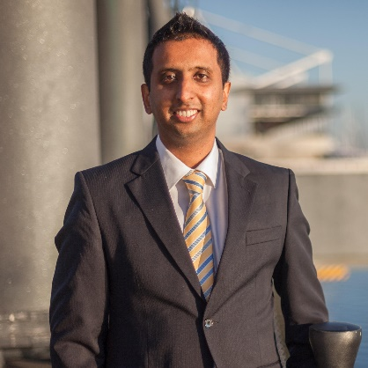
Nandu Govindankutty

Nandu Govindankutty works as a Director for the Barclays group in London focusing on Cyber Security and has proven experience of leading several key initiatives, delivering strong commercial growth using customer transformation, cultural innovation, data & analytics, social media and customer insight. He has experience working in organisations like More Than, Confused.com and Barclays designing, leading, influencing and successfully delivering global customer & client centric projects in UK, US, Africa, India, Europe & Singapore.
He was responsible for the award winning Barclays Diversity and Inclusive design initiative which was extensively and positively covered in the media and was recognised in 2013 as the top 3 customer initiatives for Diversity & Business Awards. In 2012 he rolled out a customer programme to the top 7,500 colleagues globally across Retail and Corporate bank and is responsible for driving customer experience and customer transformation using Social Media, Data propositions and innovative ways of colleague engagement.
An active public speaker in Conferences, Business Schools and Seminars and a big advocate of low-cost frugal innovation. He is also the Co-Founder of MADTA which is a consulting charity working with over 35 charities and 150 volunteers specialising in Fundraising strategy, Social Media and Talent Development which was commended by Marketing Week.

