SPEAKER PROFILE – SUJATA MADHAV CHANDRAN
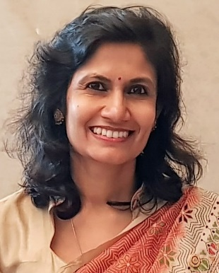
Sujata Madhav Chandran has 25 years of experience in the IT industry and is currently Global Head - Asset Leveraged Solutions, Analytics and Insights Unit and based at TCS Kochi. This is specialised group which is creating invaluable Intellectual Property and Sujata's team works in latest technologies in field of Big Data.
She has been recognised for her role in multiple transformational projects – from conceptualising to consulting, creation of optimal solution to implementation, collating best practices to replication. At TCS, Sujata is well-known for both her sessions on innovation using digital technologies and mentoring, especially women colleagues and juniors.
Sujata started her career with TCS Mumbai in 1992 as a management trainee. In her previous role at TCS, she was heading the Infrastructure Business sub-vertical for India Geography, based at Kochi. Prior responsibilities included Project Management, Quality Controller & Auditor, Sales, Pre-Sales, Products Marketing and Academic Relationship Manager,
Sujata moved to Oracle in 2012 and for 3 years worked as solution architect for various innovative projects. Her focus areas were Smart City initiatives and its citizen centric solutions apart from leading ERP solutions for Public Sector.
Aside of work, Sujata volunteers to not-for-profit organisations which work in cancer awareness creation and in mentoring youth. She is an active member of Kerala Management Association, regular contributor to community service projects through Rotary International, frequent speaker at various social platforms, and an avid reader.

