Speaker Profile
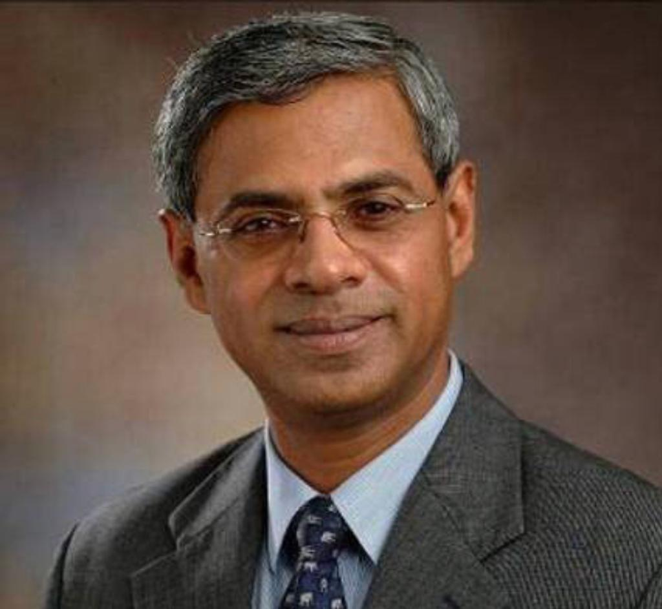
Mr. Abraham Chacko

Born in Kottayam in 1952, Mr. Chacko moved to Calcutta when he was 4 years old. After graduating from St Xavier’s College in Calcutta he joined XLRI Jamshedpur and on completing the business management program there, he joined the Sriram Group in Hyderabad and then moved to Blundel Eomite, now Garware Paints, in Mumbai. A year later he was selected by HSBC and worked with HSBC in India till 1992 when he was appointed as Deputy Country Manager of ABN AMRO Bank in the UAE. In 1999 he was appointed Country Manager of ABN AMRO in Sri Lanka. One of his mandates was to sell the bank, which he did in 2001. Thereafter he was posted to Singapore as Director Asia Pacific Region for ABN AMRO. Just before he was to retire from ABN AMRO, which by then had become RBS, he was recruited by the Federal Bank which he joined in 2011 and served a 4 years stint as its Executive Director.

He is now independent director on the board of a few companies including Liberty Insurance and Jana Small Finance Bank.

A keen golfer he has played in many courses all over the world and continues indulging in his passion with a group of like-minded friends.

